<https://www.youtube.com/watch?v=zhk9xLjrmi4>

Lagrangian:

(0) L=T-V

**T** total **kinetic** energy

**V** total **potential** energy

**qj** – generalized **coordinates**

**Qj** – generalized **forces** (the non-conservative forces)

Conservative forces – gravity, spring force

Non conservative – dumping force, ..

Lagrange equation:

(0.1) d/dt(dL/dqj)-dL/dqj=Qj , j-number of coordinates. As the number of DOF

potential energy (for mechanical systems) – is not function of time or velocity)

(..for electrons in mechanical system it is different)

Put (0) in (0.1) and use bookkeeping:

1. Is d/dt(dT/dqj)
2. Is -dT/dqj
3. dV/dqj
4. Qj

So (1)+(2)+(3)==(4) for each of j equations.

Generalized coordinates:

1. Independent
2. Complete
3. The system should be holonomic (holonomicity)

Independent – when you fix all but one coordinate, still have a continues range of movement in the free coordinate.

Complete – capable of locating all parts at all times.

In an holonomic system, the number of degrees of freedom equals the number of generalized coordinates to describe the motion. (example of constraint ball on table – not holonomic, because 2#DOF but needed 3 coor. To describe location and orientation)

Lagrangian method ‘cookbook’ :

1. Determine #DOF. Choose qj ‘s
2. Verify complete, independent, holonomic
3. Compute T,V for each j coordinate of the system
4. Compute LeftHandSide as (1),(2),(3) for each qj
5. Compute RightHandSide as Qj that goes with that qj

Computing the virtual work deltaW(non-conservative) associated with the wanted displacement delta_qj :

deltaWj = Qj delta_j ( this is a way to get scalar from vectorized elements)

notes: virtual work near equilibrium of the system, with small displacement change.

potential energy=.. out of conservative forces, (i.e 0.5 k x^2, mgh )

kinetic.. (ie. 0.5 m v^2 )

what are the non-conservative forces ?

notes:

about potential energy of a spring – consider L0 as unstretched spring length. Which is length to point of connection to the mass. Not its center of gravity.

Other x1 is length from initial measurememnt point to the location of center of gravity.

Totally we should get the dx which is the stretched length as : x1-(L0+Lmass/2)

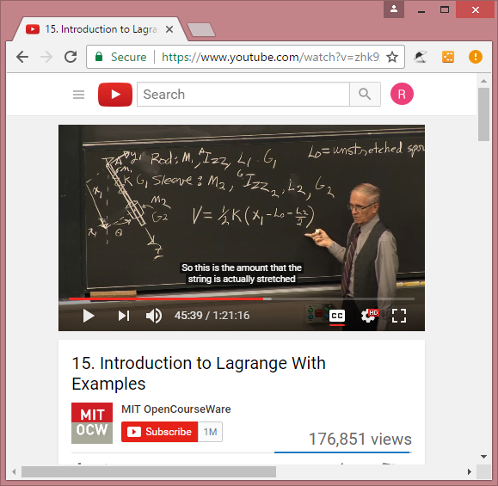

Consider good reference points.

Potential energy is the potential in the equilibrium point minus the potential energy in the new height , from those we get ~ m g dh.

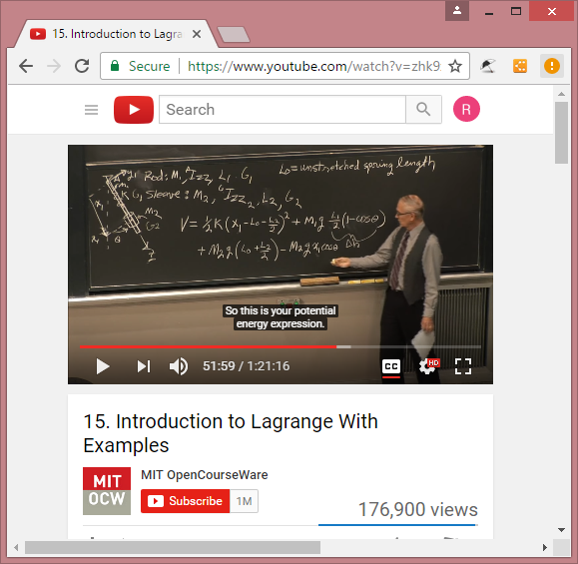

Kinetic energy – rotational and translational types.

(Izz about ref point index)

Rotetional : 0.5 Izz theta_dot^2

Translational : 0.5 m v^2 , where v is the vector in all directions, hence the squer is the double magnitude.

Accelerations types:

Coriolis

centripetal

translational

only after those: the non conservative forces are taken care of, for calculating the N-C-work.

Checking validity of the outcome is : fit to newtonian physics equations, and check in static mode (meaning velocities are zero and being at the equilibrium state)

For the given examples:

